New BFME2 World Builder Features
Addendum to the BFME1 World Builder Manual

- To help organize World Builder, we’ve added the Logical Tab and the Sound Tab to the Object Properties.
  - The Logical Tab contains all the Unit related data as well as the addition of an Upgrades section for any unit placed.
  - The Sound tab allows you to change the audio settings.
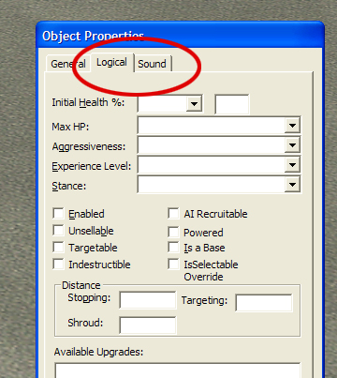

- All the scripts in WB have been tested and shifted around into their appropriate folders.
  - Sequential scripts, the act of allowing a team/unit to act out behaviors in a particular order, has been added to the Script Properties Tab of the script window.
  - On individual script conditions and script actions, you can disable those particular conditions/actions with the Enable Condition/Action box.
  - Also, you can NOT! the conditions allowing for the checking of a false condition to fire true.
- The Team window has also been cleaned up.
  - Each unit may now be built with an already assigned upgrade.
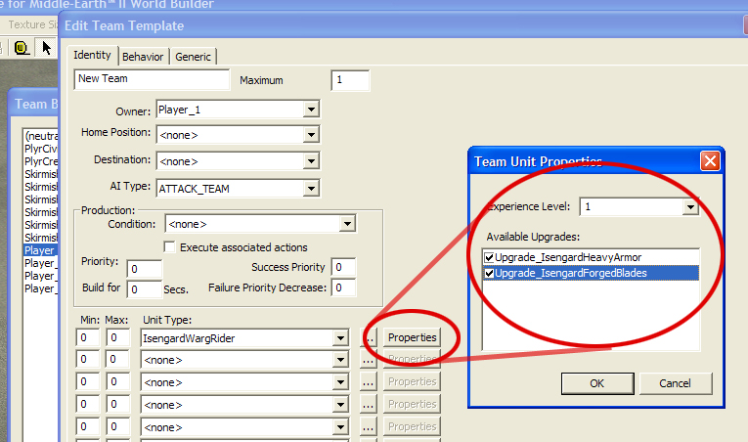

- 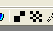 Terrain Visibility has been added to the Single & Large Tile terrain painting tool.
  - We’re now able to render portions of the terrain invisible for special situations like Celduin. Units can still walk on invisible terrain, but players can not see their units’ path. Invisible terrain is marked in World Builder with small brown squares.
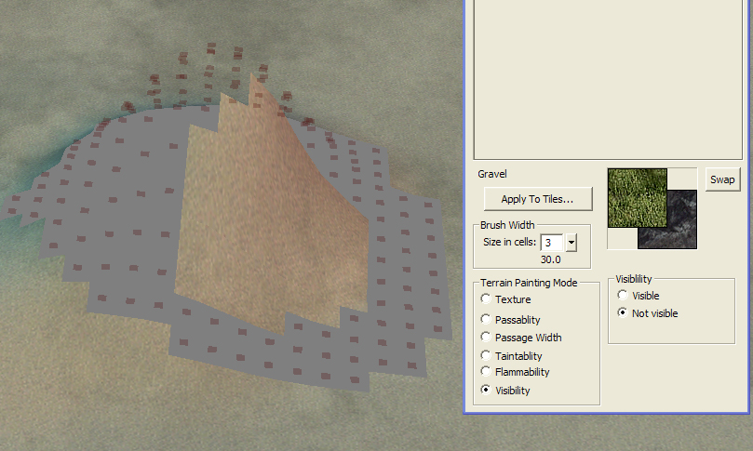

- Terrain Flammability has been added to the terrain painting tool.
  - We’ve added Igniter nuggets for weapons, fuel for objects, and 3 different fuel settings for the terrain. These different flammability settings can be applied by painting Fire Resistant(no mark), Grass(green mark), or Highly Flammable(red mark) on to the map terrain. Remember to paint flammability logically according to the textures that are on the terrain. Cliffs and the terrain underneath lakes should not catch fire, but dead grass should catch fire.
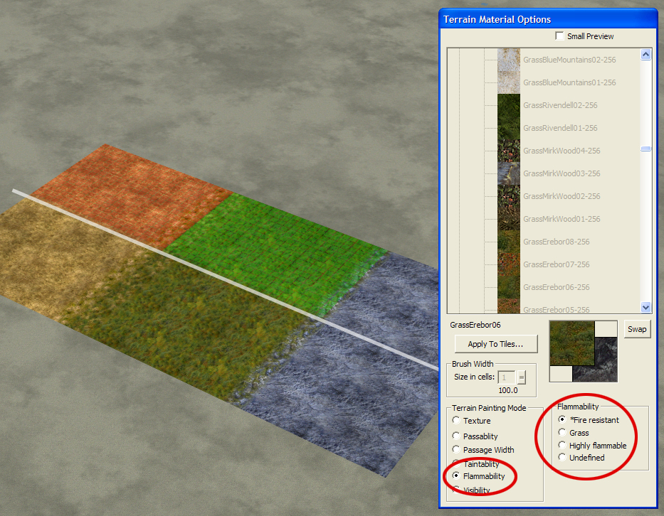

- 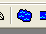 Lake/Ocean Tool –The Lake/Ocean tool now creates much prettier water using shaders embedded into W3D objects. The default water shader is WaterCaribbean, but modders will find other W3D shaders with the prefix “wtr_” in the directory \Art\W3D\WT. If you want to use ocean swell waves on your water, then you must use PCA water. The choices for PCA water are Wtr_Celduin, Wtr_Ettenmoors, Wtr_Forlindon, Wtr_Gondor, and Wtr_MMorgul.

Be sure to place the vertices in a counter-clockwise direction. Lake/Oceans that have been created in a clockwise direction have been known to cause problems.
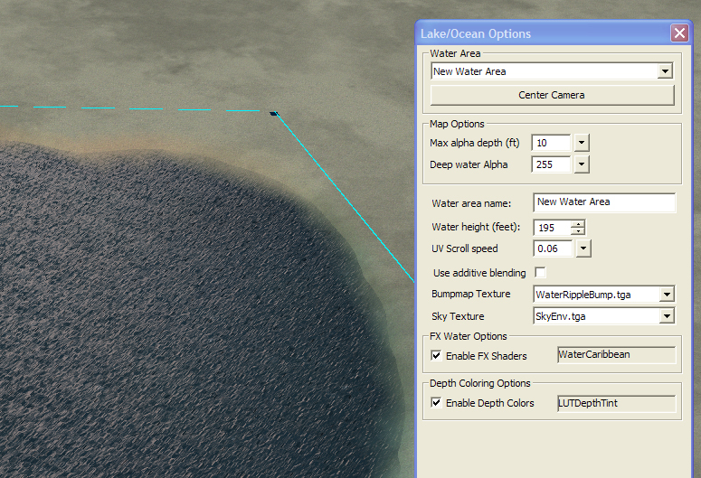

- 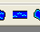 River Tool – Rivers are now simpler to place down and easier to manipulate. Just click and drag to create the first set of vertices. Then drag the connecting edge to create the end of the river.
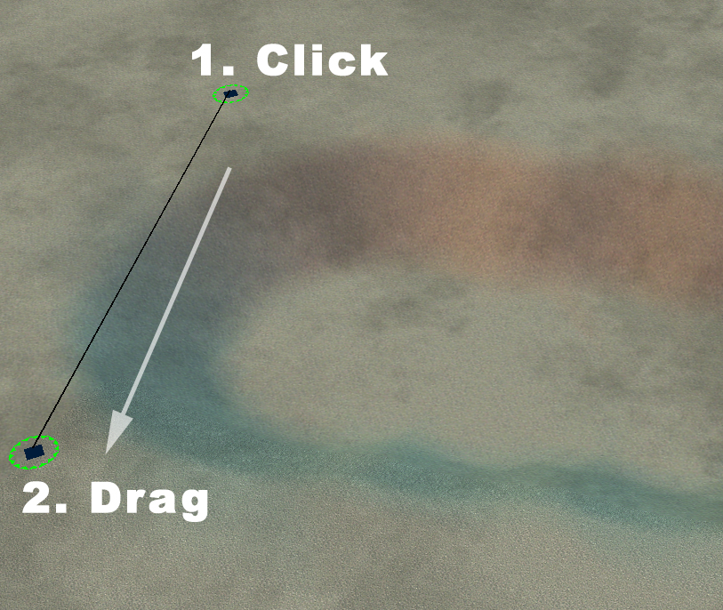
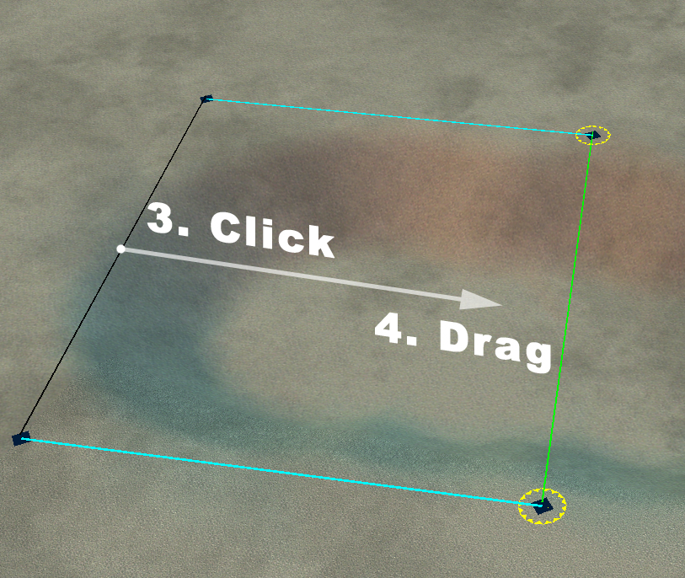

River properties such as water height are still adjusted in the River Properties box. Also, every vertex along the river is now bound to a corresponding vertex on the opposite side. You can use the River Tool to add pairs of vertices at any time along the river like laying down railroad ties. Just use the River Tool and click on the side of the river where you want to add more vertices.

- 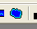 Wave Tool – This tool allows us to easily place and manipulate waves within World Builder. To place waves, use the Wave Tool to click 2 points on a body of water near the edge. The default wave is the line of foam from BfME1. There are lots of Options available to change its width, length, velocity, etc. To convert the wave into an ocean swell instead, click the “Enable PCA Wave” option at the bottom of the Options window. The PCA Wave only works on PCA lake/ocean water.

- 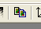 Terrain Copy/Paste Tool – Whole chunks of terrain texturing, height, impassability, flammability, and visibility can now be picked up and moved around the map. This is especially helpful for symmetrical maps. The tool has 2 modes: Selecting the desired terrain and Copy/Pasting the desired terrain.

Under “Selection Mode”, use either Drag select or Brush select to create a white selection on the terrain. You can add or subtract from the selection by clicking one of the two options under “Selection Mode”. The terrain selection should be cleared before starting a new selection.

When your selection is finished, click on “Copy Mode”, adjust the options, and left click on the terrain where you want the new terrain to be. (Copy/Pasting objects is still done the same as before)

- Post Effects – This is a rendering effect that we used to remove or shift color from the maps. For instance, it was used on the Mirkwood map to wash out much of the color. Be aware that it affects all game color, including house colors (colors associated with each player). This means that if someone chooses pink and another chooses purple, the Post Effect could make their colors indistinguishable. This feature can be accessed near the bottom of the Edit menu.

- Snow – Snowy versions of the faction buildings are determined by choosing Edit>Map Settings and changing the map weather. This defaults to “Normal”, but it should be switched to “Snowy” for snow maps.

There are 2 other snow-related changes: falling snow and snowy effects. Both of these are located in the sample map.ini file. The following code makes snow fall and is commented to the right of each line to explain what is going on. Most users will just want to leave this code unchanged by copying and pasting from the sample map.ini file.

SnowEnabled = Yes ; enable/disable snow on the map.
IsSnowing = Yes ; is it snowing today?
SnowTexture = EXSnowFlake2.tga
SnowBoxHeight = 500 ; height from which snow falls
SnowSpacing = 30 ; snow spacing -- less means more
NumberTiles = 4

SnowAmplitude = 20 ; amount of side-to-side movement.
SnowFrequencyScaleX = 0.01 ; speed of side-to-side wave movement.
SnowFrequencyScaleY = 0.005 ; speed of side-to-side wave movement.

SnowPointSize = 2 ; scale the size of snow particles.
SnowMinPointSize = 3 ; min point size
SnowMaxPointSize = 8 ; max point size

SnowPointSprites = No ; set to "no" for point-sprite emulation.
SnowQuadSize = 3 ; scale the size of snow particles when using point-sprite emulation.

SnowSpeed = 60 ; speed at which snow falls
SnowXYSpeed = X:40 Y:25

End

Snowy versions of the particle effects are also set through a lot of code(125 pages, actually) in the map.ini file. The code replaces every possible dirt effect with a snow powder alternative for that map. Rather than put all the code here, we thought it best to leave it in the sample map.ini file provided. It is better to copy/paste this code than to try to read through it all. Trust us on this one…

- Distance Fog – Fog can be added in the map.ini The color and the density of the fog can be adjusted by tweaking the following code:

Weather
HardwareFogColor = R:220 G:220 B:220
HardwareFogEnable = Yes
HardwareFogStart = 350
HardwareFogEnd = 2000
End

  - The first line is the name of the feature to be modified.
  - The second is the RGB color value of the fog. 255(white fog) is the highest and 0(black fog) is the lowest value. Off setting the numbers will give you color variants.
  - The third line indicates that the fog should render. This should say “Yes”.
  - The fourth and fifth lines indicate how thick the fog is. Fog looks best when it begins between 300-450 feet and is fully opaque around 2000 ft.
  - The last line ends the object code.

- Water reflections –The map reflection plane can be enabled by adding a few lines of code to the map.ini file and by specifying the elevation of the water. For instance, if my ocean is at 195 ft, then the map.ini should have:

WaterTransparency
ReflectionPlaneZ = 195.0;
ReflectionOn = Yes
End

  - The first line is the name of the feature to be modified.
  - The second line indicates the height of the reflection plane. This number should be the height of your ocean or primary body of water, since all water bodies share one reflection plane.
  - The third line indicates that the reflections should render. This should say “Yes”.
  - The last line ends the object code.

Note: The water reflection plane is rendered across all water planes on the map at the specified height. So if your map has waterfalls, then you must decide whether accurate reflections will be rendered on the upper water plane or the lower plane.

- 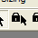 Lock Selection Tool – Helps maintain control of the current manipulation in tight complex areas. Select an object and then this click button to disable de-selection. You can cancel your selection by clicking this button again and then clicking on the map terrain.

- Set Graphics Settings – Under the View menu, you will find “Set LOD”, “Use High-Quality Shader Materials”, “Use Bump Mapped Terrain”, and “Use Shadow Mapped Shadows”. These are options for turning on/off all the new graphic eye-candy. The Set LOD feature allows you to see how your map will change when someone uses different BFME2 graphic settings. If World Builder is running slowly on your computer, then you can also turn off these features. Show Shadow Mapping will cast shadows onto other objects. To view Shadow Mapped Shadows on the terrain, Bump Mapped Terrain must also be enabled.

- Remove all Blends – This feature is helpful for starting over on a poorly blended map. It is available under Edit>Special. This is a drastic tool for a drastic situation.

- 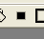 Blend all – This feature can quickly blend intricately textured maps. Use the Auto Edge Out tool and shift-click on a texture. Anywhere that texture is being used on the map will be blended.

- Hotkeys – Keyboard commands for the most commonly used tools have been added. These can be seen in the pop-up text when your mouse hovers above a button. We’ve also included a keyboard chart with all the World Builder keys.

